**EC681-MINI PROJECT**

**DIGITAL LOCK**



*Mini Project Report Submitted in partial fulfilment of the requirements for the degree of Bachelor of Technology from Maulana Abul Kalam Azad University of Technology, West Bengal*

*(Formerly known as West Bengal University of Technology)*

*Submitted By*

1. **ARINDAM GANGULY**

(Roll No.: **34900318071**, Registration No.: **183490110060** of 2018 – 2022)

1. **AYUSH PODDAR**

(Roll No.: **34900318068**, Registration No.: **183490110063** of 2018 – 2022)

1. **BISWAJIT MANDI**

(Roll No.: **34900318067**, Registration No.: **183490110064** of 2018 – 2022)

1. **ASHANUR HOSSAIN**

(Roll No.: **34900318070**, Registration No.: **183490110061** of 2018 – 2022)

1. **AVRADIP MONDAL**

(Roll No.: **34900318069**, Registration No.: **183490110062** of 2018 – 2022)

*Under the Supervision of*

**Dr. Palash Das**

Assistant Professor

Department of Electronics and Communication Engineering,

Cooch Behar Government Engineering College, Cooch Behar, West Bengal



Department of Electronics and Communication Engineering

**Cooch Behar Government Engineering College,**

Village: Harinchawra, P.O.: Ghughumari,

District: Cooch Behar, West Bengal

August, 2021

**Acknowledgement**

It is our pleasure to acknowledge our supervisor **Dr. Palash Das, Assistant Professor, Department of Electronics and Communication Engineering, Cooch Behar Government Engineering College, Cooch Behar, West Bengal**, for being not only the source of encouragement, but also a great resource of knowledge and information. We shall remain indebted to him for the immense help we have received from him.

We would also like to thank all the faculty members, technical assistants and staff of the Department of Electronics and Communication Engineering, Cooch Behar Government Engineering College, for their kind and friendly cooperation extended to us.We have no appropriate words to express sincere thanks to our family members for their continuous support and encouragement.

| ____________________________  **ARINDAM GANGULY**  **(Roll no: 34900318071)** | ___________________________  **AYUSH PODDAR**  **(Roll no:34900318068)** |
| --- | --- |
| ____________________________  **BISWAJIT MANDI**  **(Roll no:34900318067)**    ____________________________  **AVRADIP MONDAL**  **(Roll no:34900318069)** | ____________________________  **ASHANUR HOSSAIN**  **(Roll no:34900318070)** |
|  |  |

**Abstract**

In this paper, we propose a smart digital door lock system for home automation. A digital door lock system is equipment that uses the digital information such as a secret code, semiconductors, smart card, and fingerprints as the method for authentication instead of the legacy key system. In our proposed system, a Proteus ISIS Professional is embedded in a digital door lock and the door lock acts as a central main controller of the overall home automation system. Technically, our proposed system is the network of sensor nodes and actuators with digital door lock as base station. A door lock system proposed here consists of RFID reader for user authentication, touch LCD, motor module for opening and closing of the door, sensor modules for detecting the condition inside the house, communication module, and control module for controlling other modules. Sensor nodes for environment sensing are deployed at appropriate places at home. Status of individual Proteus ISIS Professional modules can be monitored and controlled by the centralized controller, digital door lock. As the door lock is the first and last thing people come across in entering and leaving the home respectively, the home automation function in digital door lock system enables the user to conveniently control and monitor home environment and condition all at once before entering or leaving the house. Furthermore, it also allows users to remotely monitor the condition inside the house through the Internet or any other public network. The biggest advantage of our proposed system over existing ones is that it can be easily installed when and where necessary without requirement of any infrastructures and proper planning.



| **Chapter No** | **Name of the Chapter** | **Page No** |
| --- | --- | --- |
| **1** | | **INTRODUCTION** | | --- | | **5-6** |
| **2** | **OBJECTIVE** | **7** |
| **3** | **COMPONENTS USED** | **8** |
| **4** | **COMPONENTS DESCRIPTION** | **9-14** |
| **5** | **PROCEDURE** | **15-16** |
| **6** | **CIRCUIT DIAGRAM** | **17** |
| **7** | **CONCLUSION** | **18** |
| **8** | **REFERENCES** | **19** |



An **electronic lock** (or **electric lock**) is a [locking device](https://en.wikipedia.org/wiki/Lock_(security_device)) which operates by means of electric current. Electric locks are sometimes stand-alone with an electronic control assembly mounted directly to the lock. Electric locks may be connected to an [access control](https://en.wikipedia.org/wiki/Access_control) system, the advantages of which include: key control, where keys can be added and removed without rekeying the lock cylinder; fine access control, where time and place are factors; and transaction logging, where activity is recorded. Electronic locks can also be remotely monitored and controlled, both to lock and to unlock.

The programmable electronic lock system is realized by programmable keys, electronic locks and software. When the identification code of the key matches the identification code of the lock, all available keys are operated to unlock. The internal structure of the lock contains a cylinder, which has a contact (lock slot) that is in contact with the key, and a part of it is an electronic control device to store and verify the received identification code and respond (whether it is unlocked). The key contains a power supply device, usually a rechargeable battery or a replaceable battery in the key, used to drive the system to work; it also includes an electronic storage and control device for storing the identification code of the lock.

The software is used to set and modify the data of each key and lock.

Using this type of key and lock control system does not need to change user habits. In addition, compared with the previous mechanical device, its advantage is that only one key can open multiple locks instead of a bunch of keys like the current one. A single key can contain many lock identification codes; which can set the unlock permission for a single user.

A **smart lock** is an electromechanical lock which is designed to perform locking and unlocking operations on a door when it receives such instructions from an authorized device using a wireless protocol and a cryptographic key to execute the authorization process. It also monitors access and sends alerts for the different events it monitors and some other critical events related to the status of the device. Smart locks can be considered part of a smart home.

Most smart locks are installed on mechanical locks (simple types of locks, including deadbolts) and they physically upgrade the ordinary lock. Recently, smart locking controllers have also appeared on the market.

Smart locks, like the traditional locks, need two main parts to work: the lock and the key. In the case of these electronic locks, the key is not a physical key but a smartphone or a special key fob configured explicitly for this purpose which wirelessly performs the authentication needed to automatically unlock the door.

Smart locks allow users to grant access to a third party by means of a virtual key. This key can be sent to the recipient smartphone over standard messaging protocols such as e-mail or SMS. Once this key is received the recipient will be able to unlock the smart lock during the time previously specified by the sender.

Smart locks are able to grant or deny access remotely via a mobile app. Certain smart locks include a built-in Wi-Fi connection that allows for monitoring features such as access notifications or cameras to show the person requesting access. Some smart locks work with a smart doorbell to allow the user to see who and when someone is at a door. Many smart locks now also feature Biometric features, like fingerprint sensors. Biometrics are becoming increasingly popular because they offer more security than passwords alone. This is because they use unique physical characteristics rather than stored information.This means that biometric authentication isn’t about remembering something but about recognizing something about yourself.

Smart locks may use Bluetooth Low Energy and SSL to communicate, encrypting communications using 128/256-bit AES.



For this project, NOR and XOR gates, switches, LED’s, and resistors are used within this project. The “key code” and “data entry” switches/logic state are the two eight position DIP switches. Also, whenever a password in the “enter” switch is pressed in – the light will become either red if the password is incorrect or green if the password is correct. Above all, individuals can receive alerts directly to his/her mobile devices each time a wrong password has been attempted.

For this project, individuals will implement a password security system with help of some Logic Gates. The “**Digital Lock**” project will give individuals the opportunity to become familiar with using NOR and XOR logic gates within a circuit. The learning Objective of this project are :

* To use **X-OR** as a bit of Comparators.
* Getting familiar with different Logic Gates.
* Using **NOR** gate as a controlled inverter.



* **1x4 INPUT OR GATE**
* **3x NOR GATE**
* **4x XOR GATE**
* **12x RESISTOR**(10kohm)
* **2x4 POSITION DIP SWITCHES**
* **1x PUSH SWITCH**



***OR GATE:***

The **OR gate** is a logic gate that outputs 1 (true) when at least one of its inputs is 1 (true). That means that if both of its inputs are 0, the output will be 0.

The best way to remember an OR operation is "one or the other, or both."

The HCF4072B DUAL 4 INPUT OR GATE provides the system designer with direct implementation of the positive logic OR function and supplement the existing family of CMOS gates. It simply follows the function same as 2 input OR Gate except that the inputs here are 4. It gives logic “HIGH” when any one of the inputs is “HIGH”, and logic “LOW” when all inputs are “LOW”.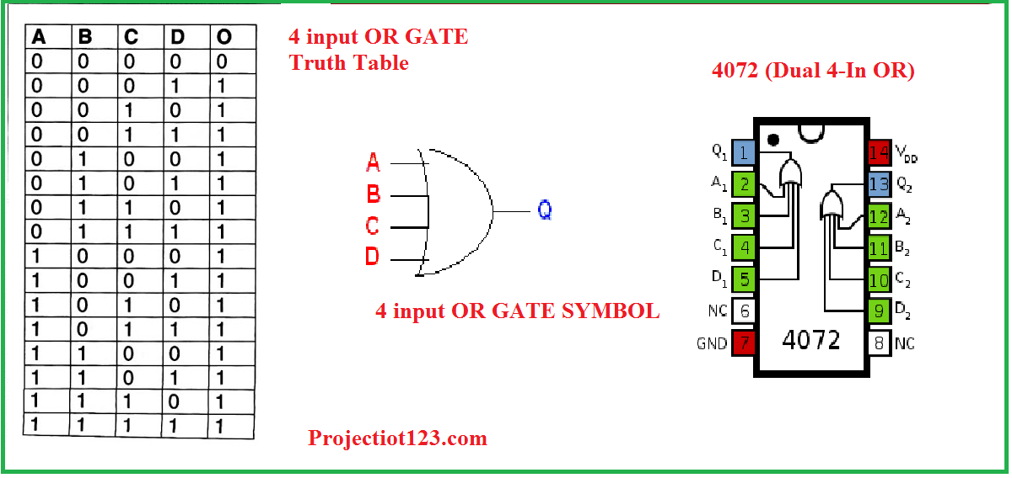

***XOR GATE:***

XOR gate (sometimes EOR, or XOR and pronounced as Exclusive OR) is a digital logic gate that gives a true (1 or HIGH) output when the number of true inputs is odd. An XOR gate implements an exclusive or from mathematicallogic; that is, a true output results if one, and only one, of the inputs to the gate is true. If both inputs are false (0/LOW) or both are true, a false output results. XOR represents the inequality function, i.e., the output is true if the inputs are not alike otherwise the output is false. A way to remember XOR is "must have one or the other but not both".

XOR can also be viewed as addition modulo 2. As a result, XOR gates are used to implement binary addition in computers. A half adder consists of an XOR gate and an AND gate. Other uses include subtractors, comparators, and controlled inverters.

In this project we use XOR gate as a bit comparator.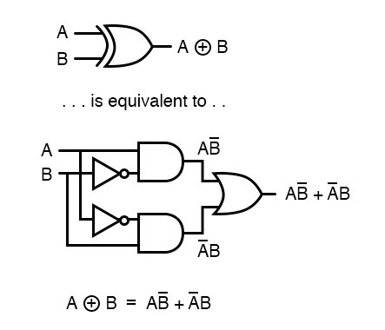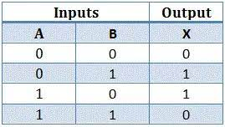

***NOR GATE:***

The **NOR gate** is a digital logic gate that implements logical NOR - it behaves according to the truth table to the right. A HIGH output (1) results if both the inputs to the gate are LOW (0); if one or both input is HIGH (1), a LOW output (0) results. NOR is the result of the negation of the OR operator. It can also in some senses be seen as the inverse of an AND gate. NOR is a functionallycomplete operation—NOR gates can be combined to generate any other logical function. It shares this property with the NAND gate. By contrast, the OR operator is *monotonic* as it can only change LOW to HIGH but not vice versa.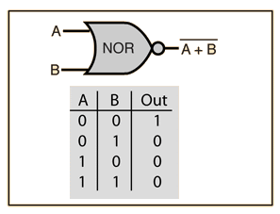

In most, but not all, circuit implementations, the negation comes for free—including CMOS and TTL. In such logic families, OR is the more complicated operation; it may use a NOR followed by a NOT. A significant exception is some forms of the domino logic family.

The original Apollo GuidanceComputerused 4,100 integrated circuits (IC), each one containing only two 3-input NOR gates.

***DIP SWITCHES:***

A **DIP switch** is a manual electric switch that is packaged with others in a group in a standard dual in-line package (DIP). The term may refer to each individual switch, or to the unit as a whole. This type of switch is designed to be used on a printed circuit board along with other electronic components and is commonly used to customize the behavior of an electronic device for specific situations.

DIP switches are an alternative to jumper blocks. Their main advantages are that they are quicker to change and there are no parts to lose.

DIP switch with 4 individual switch positions. The pins have .1"(2.54mm) spacing - fits great into a breadboard! Works great as general control switches**.**

**Features:**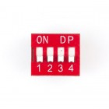

* 4 individual switch positions
* 2.54mm pin spacing
* General control switches

Here we can make 4 input **key codes** and **Data entry** switches with the help of DIP switches.

***LED:***

A **light-emitting diode** (**LED**) is a semiconductor light source that emits light when current flows through it. Electrons in the semiconductor recombine with electron holes, releasing energy in the form of photons. The color of the light (corresponding to the energy of the photons) is determined by the energy required for electrons to cross the band gap of the semiconductor.White light is obtained by using multiple semiconductors or a layer of light-emitting phosphor on the semiconductor device.

Appearing as practical electronic components in 1962, the earliest LEDs emitted low-intensity infrared (IR) light. Infrared LEDs are used in remote-control circuits, such as those used with a wide variety of consumer electronics. The first visible-light LEDs were of low intensity and limited to red. Modern LEDs are available in visible, ultraviolet (UV), and infrared wavelengths, with high, low, or intermediate light output.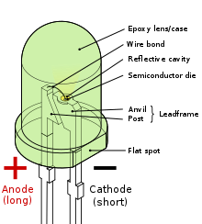

Early LEDs were often used as indicator lamps, replacing small incandescent bulbs, and in seven-segment displays. Recent developments have produced high-output white light LEDs suitable for room and outdoor area lighting. LEDs have given rise to new types of displays and sensors, while their high switching rates are useful in advanced communications technology.

***PUSH SWITCH:***

A **push switch (button)** is a momentary or non-latching switch which causes a temporary change in the state of an electrical circuit only while the switch is physically actuated. An automatic mechanism (i.e. a spring) returns the switch to its default position immediately afterwards, restoring the initial circuit condition. There are two types: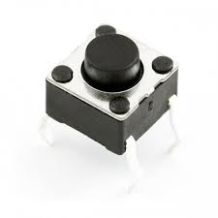

* A 'push to make' switch allows electricity to flow between its two contacts when held in. When the button is released, the circuit is broken. This type of switch is also known as a Normally Open (NO) Switch. (Examples: doorbell, computer case power switch, calculator buttons, individual keys on a keyboard)
* A 'push to break' switch does the opposite, i.e. when the button is not pressed, electricity can flow, but when it is pressed the circuit is broken. This type of switch is also known as a Normally Closed (NC) Switch. (Examples: Fridge Light Switch, Alarm Switches in Fail-Safe circuits)

Many Push switches are designed to function as both 'push to make' and 'push to break' switches. For these switches, the wiring of the switch determines whether the switch functions as a 'push to make' or as a 'push to break' switch.



* Set the power supply to 9 volts, and place voltage and ground.
* Connect voltage to each “KEYPAD LOCK” switch and each “DATA ENTRY.”
* Connect a “KEYPAD LOCK” switch to pins of the XOR gate, as well as, connect a “DATA ENTRY” to pins of the XOR gate.
* Allow all wires to come from pins of the all XOR gate to pins of the 4 INPUT OR gate.

* Connect the pin of the OR gate to the pin of one of the NOR gate.

* Place a wire from the point of the wire from OR gate to NOR gate, to the other pin of the same NOR gate.
* Connect the pushbutton switch to ground.
* Place a wire from pin to a light-emitting diode.
* Place a wire from the output of the OR gate to the pin of the NOR gate, as well as, a wire from the pin of the same NOR gate to a 10kΩ resistor, and place a wire from the pin to the pushbutton switch with the resistor.
* Connect the 10kΩ resistor to voltage.
* Place a wire from the pin of the NOR gate to a light-emitting diode.
* Place a 10Ω resistor to each light-emitting diode.
* Connect each 10Ω resistor to ground.



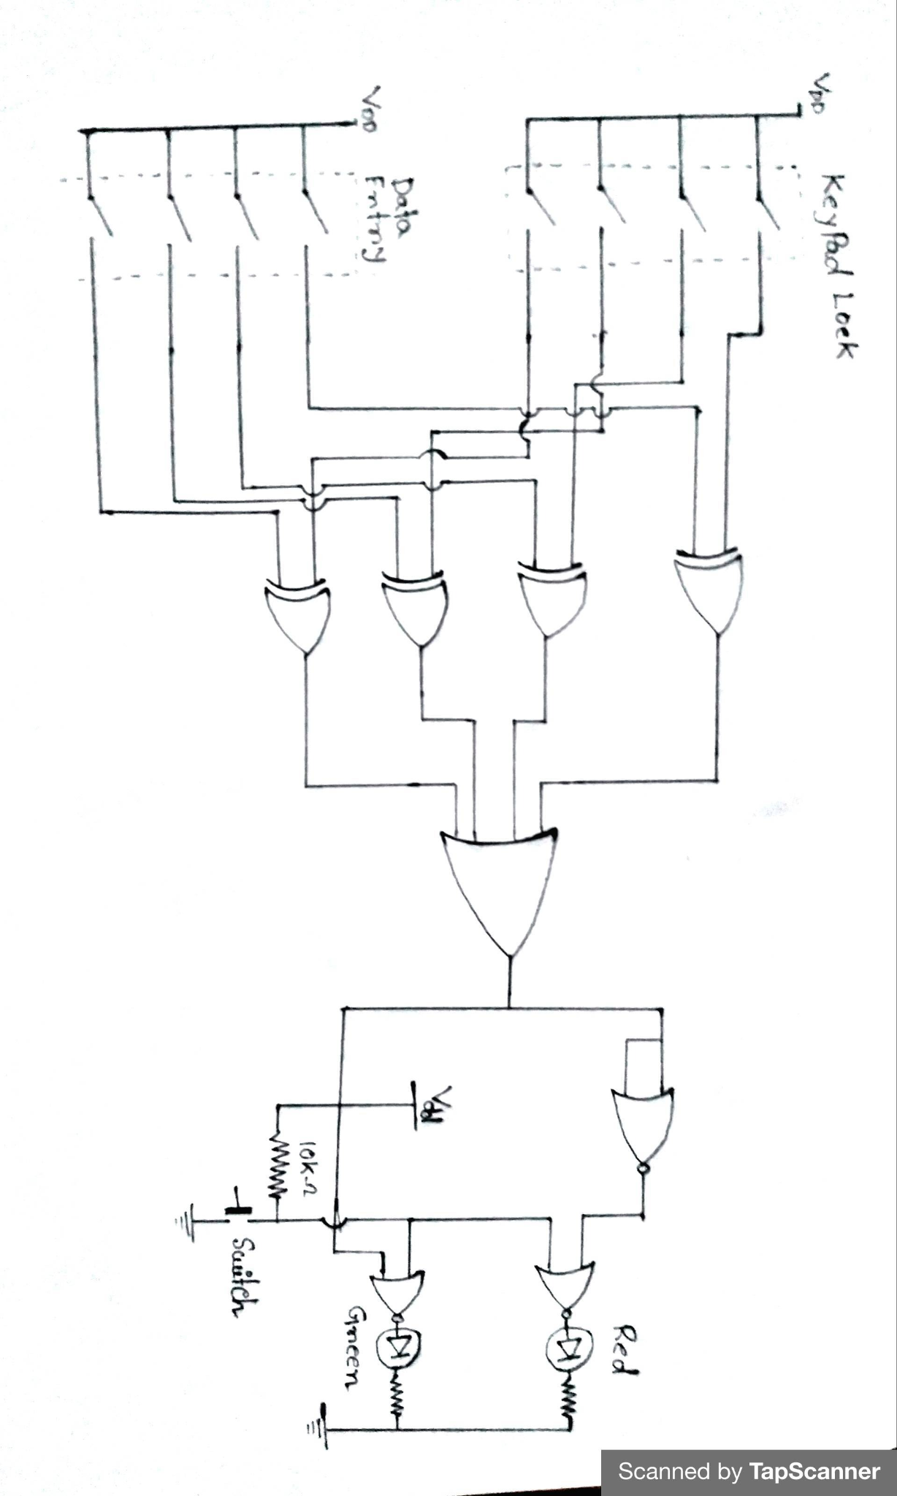



In our belief, we can confirm that the introduced system could be easily implemented and can be seen to be manufactured in large scale in the upcoming future. It will prove the specificity, speciality and low cost of the system. This type of technology will be very helpful for the person who is a self independent one particularly in case of partially disabled beings.

Because the project spans a wide range of disciplines involving both hardware and software, there were a lot of tools for us to learn and use.

If we were to do the project again one of the things we would do differently is to read more about what is required of the components to function together before starting our coding

Additionally, rather than getting stuck on one problem in the early stage of the project one should focus on going further with the other goals rather than spending too much time attempting to fix one specific problem. In the end we managed to get a working system, despite some parts of the project being modified or eliminated because of the limited time for this project.



* Hoepfner, Wolfram (1970). "Ein Kombinationsschloss aus dem Kerameikos". *Archäologischer Anzeiger*. **85** (2): 210–213.
* Permutation padlock. Found in [Google Books](https://en.wikipedia.org/wiki/Google_Books).
* Improvement in permutation padlocks [Google Books](https://en.wikipedia.org/wiki/Google_Books).
* "IMPROVEMENT IN TUMBLERS FOR PERMUTATION-LOCKS" by Joseph Loch, U.S. patent 200070, 5 February 1878. Found in [Google Books](https://en.wikipedia.org/wiki/Google_Books).
* Rae, Andrew E. ["Combination lock"](https://patents.google.com/patent/US4290286A). *Google Patents*.
* ["Kaba-MAS X-09 and CDX-09 High Security Locks"](http://www.kaba-mas.com/pdf/brochures/x_09.pdf) (PDF). December 2010. p. 8.
* ["Operating Instruction for the X-09 Type 1F High Security Electronic Lock"](https://web.archive.org/web/20110728015227/https://portal.navfac.navy.mil/portal/page/portal/NAVFAC/NAVFAC_WW_PP/NAVFAC_NFESC_PP/LOCKS/PDF_FILES/X-09_Operating_Instructions.pdf) (PDF). December 2010. Archived from [the original](https://portal.navfac.navy.mil/portal/page/portal/NAVFAC/NAVFAC_WW_PP/NAVFAC_NFESC_PP/LOCKS/PDF_FILES/X-09_Operating_Instructions.pdf) (PDF) on 28 July 2011.
* T. P. J. Alba, ‘Spectrum sensing based on specialized microcontroller based white space sensors : Measuring spectrum occupancy using a distributed sensor grid’, Master’s thesis, Royal Institute of Technology, School of Information and Communication Technology, Stockholm, Sweden, 2013, TRITA-ICT-EX; 2013:177.